Integrated Math 1 Name:

Final Exam Review

Trimester C

1. Solve the expression for

2. Solve each for x.

1. b.

3. Solve each inequality and graph your solution on a number line.

a. b.

4. Solve the system of equations using any method:

5. You have decided to give your best friend a bag of red and green marbles for his birthday. You friend likes green marbles better than red ones, so the bag contains twice as many green marbles as red. The label on the bag says it contains 84 marbles. Write a system and solve to find how many of each type of marble is in the bag?

6. The cafeteria sold pizza slices and burritos. The number of pizza slices sold was 20 less than twice the number of burritos sold. Pizza sold for $2.50 a slice and burritos sold for $3.00 each. The cafeteria collected a total of $358 for selling these two items. Write a system and solve to find how many of each were sold?

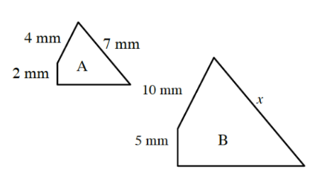

7. Anaya enlarged figure A so that it was similar to figure B. Her

diagram is shown at right.

a. What is the scale factor?

b. What is the value of *x*?

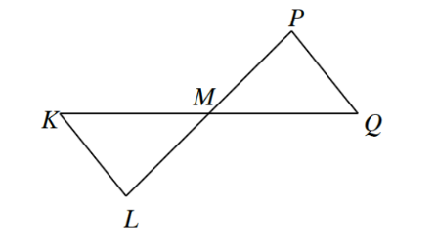8. Construct a flowproof to prove that

∆KML $≅$ ∆QMP

Given: M is the midpoint of both and .

9. Construct a flowproof to prove that the two triangles are congruent.

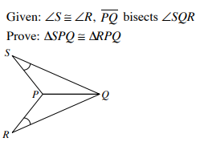

10. Graph the points $A\left(0, 3\right), B\left(0, 6\right), C\left(3, 6\right), and D\left(5, 1\right).$

Connect the points to create line segments AB, BC, CD and AD.

1. What is the perimeter?
2. What is the area?
3. Describe all the relationships that exist between the diagonals ($\overline{AC} and \overline{BD})$. Prove this algebraically.
4. Find the point where the diagonals intersect algebraically. (Hint: Write equations for each diagonal to help or find another way).
5. The shape seems to be a Kite. Kites have the property of having Two sets of Congruent sides. Prove that the shape above has this property.

11. Graph the system of inequalities and

shade the solution(s):

12. Write an equation of the exponential function that contains the points $\left(1, 6\right)and (4, 162)$.

Based on each graph below, write the equation of the exponential function .

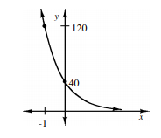13. 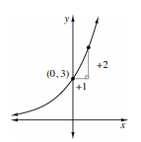 14.

15. Mr. Bruns has a block of ice on his foot because he hurt it playing Mr. Barber in Basketball. The block of ice weighs 60 grams and is melting at 5% an hour. How much will remain solid after 8 hours?

16. A survey of 155 recent high school graduates found that 130 had driver’s licenses and 58 had jobs. Twenty-one said they had neither a driver’s license nor a job. Is there an association between having a driver’s license and a job among the recent graduates? Use the table on the left to create a two-way table, then use the table on the right to show a relative-frequency table.

|  |  |  |  |
| --- | --- | --- | --- |
|  | Job | No Job |  |
| License |  |  |  |
| No License |  |  |  |
|  |  |  |  |

|  |  |  |
| --- | --- | --- |
|  | Job | No Job |
| License |  |  |
| No License |  |  |

17. Sullivan spent $11.19 on a bag containing red and blue candies. The bag weighed 11 pounds. The red candy costs $1.29 a pound and the blue candy costs $0.79 a pound. Write an equation or a system of equations that models each situation and use it to find How much red candy did Sullivan have?

Use the triangle congruence conditions to decide whether each pair of triangles must be congruent. Base each decision on the markings, not on appearances. Justify each answer.

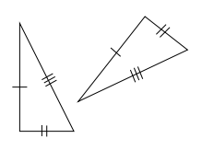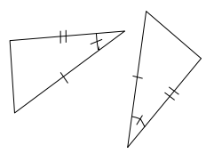

18. 19.

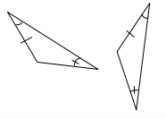

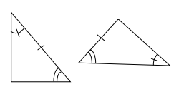20. 21.

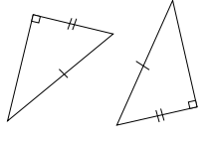

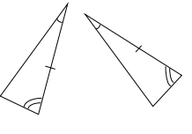22. 23.

24. Simplify the expression .

25. Suppose a sequence of numbers has values of  and .

Greg wants this sequence to be **arithmetic**.

Write the first 5 terms of Greg’s sequence. ______, ______, ______, ______, ______

Write an explicit equation for Greg’s sequence.



Use your equation to find the 10th term of Greg’s sequence.

Hailey wants this sequence to be **geometric**.

Write the first 5 terms of Hailey’s sequence. ______, ______, ______, ______, ______

Write an explicit equation for Hailey’s sequence.



Use your equation to find the 10th term of Hailey’s sequence.

26. Solve each equation for *x*. Clearly show your work.

a)  b) 

c)  d) 

27. In 2018 (year 0), Thomas has an annual salary of $50,000 per year. At his company, employees are given options of what kind of raises they prefer.

Option 1: Thomas is allowed to take a raise of $2500 each year. Write an equation and find how much he would make in 2030 based off this option.

Option 2: Thomas is allowed to take a 4% raise each year. Write an equation and find how much he would make in the year 2030 based off this option.

28. Grace L. felt like she was playing a lot of minutes in her soccer games. She had her friend Grace W. record how long she played in her last 15 games. The information is provided in minutes. (A high school game is 70 minutes)

5, 32, 35, 40, 40, 41, 48, 52, 53, 54, 58, 60, 60, 62, 70

Use this information to complete the following.

Sketch a combination of a box and whiskers and histogram. (Use intervals of 10 minutes)

Find the 5 number summary for the data. (Min, Q1, Median, Q3, Max)

Find the median and standard deviation for the data.

Write two interesting facts about Grace’s Data.

If you were looking to report a “typical” value for Grace’s playing time, would you use the mean or median and why?

On a typical game day, does Grace play more or less than half the game?

Mr. Barber tracked his playing time from when he played in high school. He reported his IQR was 12 minutes. Knowing this, who has data that is more spread out?