Algebra 2 Name:__________________________________

Test #1 Review

**Solving Equations & Evaluating**

1. **Evaluate each expression if x = 3, y = -2 and z = 4.**
2. 2xyz – y c. y2 + 4(x+z)-(z-y)
3. **Find the dimensions for the isosceles triangle pictured if the perimeter is 52 cm.**

2x + 3

x - 4

1. **Solve each for x.**
2. $\sqrt{-2x+8}=12$ b. 2(x-4) = 16 c. -3(-x+2) – 7 = 7(x+1)

d. $\frac{2x+1}{5}=\frac{3}{4}$ e. $\frac{x}{3}+12=9$ f. (13x-14)2 = 9

**Solving Inequalities**

1. **Solve and GRAPH each inequality on a number line.**
2. -6(2x-10) + 12x ≤180 b. 3x + 1 > 7 or 5(x-1) < -10
3. **Find the error in each problem. If there isn’t one, right “ALL GOOD”.**

**Student A Student B**

**Solving Absolute Value & Inequalities**

1. **Solve each absolute value. Check your answers. Circle all final answers.**
2. 3|2x+1| = -12 b. $\frac{|x-3|}{5}+7$ = 12
3. **Solve each absolute value inequality and graph the answer on a number line.**
4. 2|x-7| + 1 > 5 b. |3x + 4| ≤ 20
5. **Write and solve an inequality to match the scenario.**

The Seaholm Soccer team is hosting their annual car wash. They purchased $150 in supplies and charge $4 per car and $6 per truck. If they washed 15 trucks, at least how many cars must they wash to break even?

Chapter 2 Stuff

**Find the slope of each line.**

**1.** 3*x −* 5*y* = 15 **2.** through (−2, 7) and (4, 1)

**Write an equation in slope-intercept form for each scenario.**

**3. a.** through (6, 1) and perpendicular to *y* **= ***x* +  **b.** through (0,3) & parallel to 2x + 3y = 18

**Graph each function.**

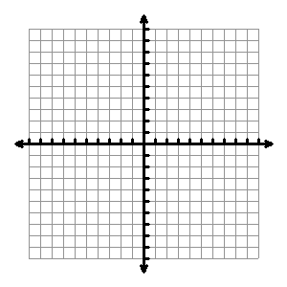**4.** *y* **= ***x* + 1 **5.** *4x – 2y = 12*

**7.** *y*  - 4 = ½ (x-8)



**10. Write in slope intercept form the equation of a line** Through(1, 5) and (−3, 3)

**11. Write the equation of a line** Through (−4, 1) with an undefined slope

**12.** The table below displays the enrollment at Westside High during the years 1996–2001.

|  |  |
| --- | --- |
| **Year** | **Enrollment** |
| 1996 | 1582 |
| 1997 | 1635 |
| 1998 | 1674 |
| 1999 | 1723 |
| 2000 | 1745 |
| 2001 | 1801 |

1. Given that the equation of this line of best fit is , estimate the enrollment in 2015 (use 1996 as year zero).
2. Explain what the 42 means in the context of this problem.
3. Interpret the y-intercept of 1588 in context.

**13.** Find the slope and all intercepts of the line 3*x* - 2*y* = 18.

**14.** At a school play, children’s tickets cost $3 each and adult tickets cost $7 each. The total amount of money earned from ticket sales equals $210. Write a linear model that relates the number of children’s tickets sold, *c*, to the number of adult tickets sold, *a*.

a. Write the equation.

b) How many children’s tickets were sold if 24 adult tickets were sold?

c) Explain the meaning of the *c*-intercept.

**15.** Mr. Thompson is on a diet. He currently weighs 260 pounds. He loses 4 pounds per month. Write a linear model that represents Mr. Thompson’s weight after *m* months.

b) After how many months will Mr. Thompson reach his goal weight of 220 pounds?

**16.** A 12 mile cab ride costs $8.10, while a 23 mile cab ride cost $11.40. Write an equation to model how much a cab ride will costs for *x* amount of miles. Then find out how much a 16 mile cab ride would cost.

17. Graph and shade the following linear inequalities.

****y < -3x + 1 4x + 2y ≥ 10

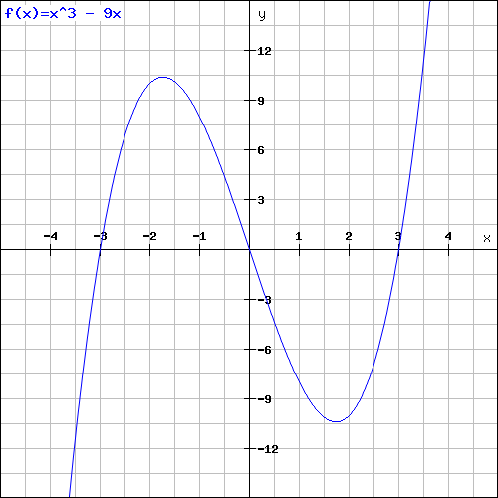18. Answer the function questions for the graph below. Assume the ends of the graph go on forever.

A. Domain: Range:

B. Increasing: Decreasing:

C. x-intercept(s): y-intercept:

End Behavior: