**Algebra 2 3Tri B Name:_________________________________**

**Final Exam Review (Chapters 6, 7, & 9)**

**Winter 2018 Date: ____________________ Hour: _______**

**Chapter 6 - Polynomials**

1. Divide using synthetic division.
   1. 
2. Determine the end behavior of the graphs of these functions.
   1.  b. 
3. Write an equation in standard form of a second degree polynomial that has zeros of 7 and -2.
4. Write an equation in standard form of a third degree polynomial that has zeros of 5 and 3*i*.
5. A polynomial equation has roots 3, -4i and 2 – 3i, what is the least possible degree of the polynomial?
6. Test to see if -3 is a possible root of 6x3 – 4x2 + x – 3 = 0.
7. Is x + 1 a factor of f(x) = 5x4 – 8x2 + 15x – 10?
8. Find p(4) if p(x) = -3x3 – 7x2 + 2x + 12 (without the use of a calculator)
9. Solve for x by factoring.
   1. x4 – 3x2 – 18 = 0
10. For the following polynomial 2x3 + 2x2 - 8x – 8 = 0,
11. List all the possible rational roots (Rational Root Theorem)
12. Graph to find one that works and test it with synthetic division.
13. Use part b to help find the rest of the solutions (there should be 3!)
14. For each function, find the following and then graph. You may have to simplify the first one. (without a calculator)

**f(x) = x4 - 5x2 + 4 g(x) = x(x-1)2(x+4)**

Domain:

Range:

x-intercept(s) with multiplicities:

y-intercept:

Domain:

Range:

x-intercept(s) with multiplicities:

y-intercept:

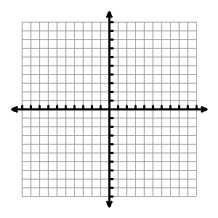

1. Graph a 7th degree polynomial function with a positive

leading coefficient given its zeros are 3 with a multiplicity of 2,

0 with a multiplicity of 1, 5 with a multiplicity of 2,

and -4 with a multiplicity of 2.

1. Describe the combinations of possible number and types of roots of the equation x4 – 4x2 = 0.

**Chapter 7 – Radicals**

1. Let . Find:
   1.  b. 

**For #15 – 20, let f(x) = 2x + 5 and g(x) = x2 – 3x + 2**

1. f(7) + g(3) 16. 4f(7) + 6g(3) 17. f(x) – g(x)
2. (g + f)(x) 19. $(f o g)(-2)$ 20. g(f(3))
3. Describe how the graph $y= \sqrt{x-4}-2$ is translated from the graph of $= \sqrt{x}$.
4. Given $f\left(x\right)= \sqrt{x-9}$, state the **domain and range** of f(x), then find **the inverse** of the function.

**Solve. Check for extraneous solutions (without a calculator)**

23. 24. 

1.  26. 

**Simplify. (without a calculator).**

27. 28.  29. 

30. 31.  32. 

33.  34.  35. 

**Continue simplifying (without a calc)**

36.  37. 

1. For each function, find the following and then graph. (Without a calculator, which means you should graph the parent function first!)
   1.  b. 

Domain: Range:

Domain: Range:



d. $g\left(x\right)=({x+3)}^{2}$**and its inverse $g^{-1}(x)$**

1. $f\left(x\right)= \sqrt[3]{x+3}-2$ $g^{-1}(x)$**=**

Domain: Range:

x-intercept(s): y-intercept(s):

Domain: Range:

Domain of g-1(x): Range of g-1(x):



**Chapter 9 – Rational Functions**

**Multiply or Divide.**

1.  40.

**Add or Subtract.**

1.  42. 

**Simplify.**

1.  44. 

**Solve each equation.**

1.  46. 
2.  48. 

**Simplify**

49. 50.

**Determine where points of discontinuity are (Holes and Vertical Asymptotes) if there are any. Then find the Horizontal Asymptote.**

1. f(x) = $\frac{2x-2}{x^{2}-1}$ 52. g(x) = $\frac{\left(x-1\right)\left(x-2\right)(x-3)}{\left(x+2\right)\left(x-3\right)(x+1)}$

**Find the horizontal and vertical asymptotes and points of discontinuity, then graph.**

53.  54.  55. 

HA: _________________

VA: _________________

Holes: _______________

X-int :____________

Y- Int: _______________

HA: _________________

VA: _________________

Holes: _______________

X-int :____________

Y- Int: _______________

HA: _________________

VA: _________________

Holes: _______________

X-int :____________

Y- Int: _______________





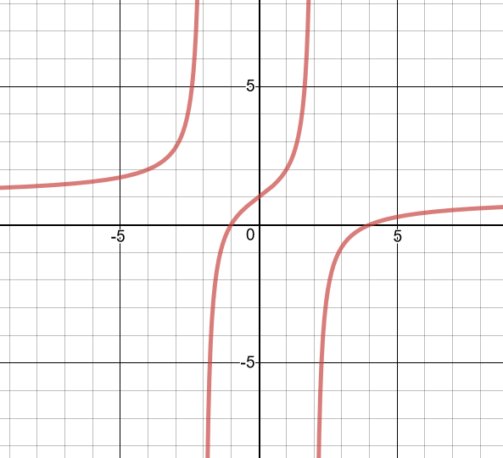

58. Find the equation of the graph.