Honors Integrated Math 3 Name:

Chapter 8/9/10 Review

1. Write an equation in Standard Form for the area of the shaded region and find the zeroes *(also known as x-intercpets).*

The radius of the BIG circle is: *6x - 2*

The radius of the little circle is: *3x + 1*

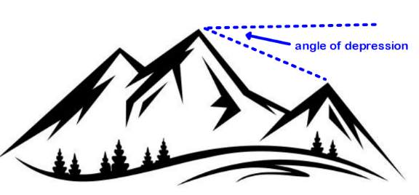2. You are standing at the peak of a mountain that is 9,000 ft. above sea level. The angle of depression from this peak to a nearby smaller peak is . On your map these two peaks are represented by points that are 1 inch apart. If each inch of your map represents .6 miles, and there are 5280 feet in a mile, how many feet above sea level is the second peak?

3. XOY is a sector of 

Radius OY = 6cm and central .

a. Find the length of 

1. Find the perimeter of sector XOY

4. *ABCD* is a square with area 100.  is inscribed in *ABCD*.  intersects the circle at *X* and *Y*, with  between *B* and *X*. Find *DX*.

5. Given:  with radius 10

 

Find:  to the nearest tenth

6. 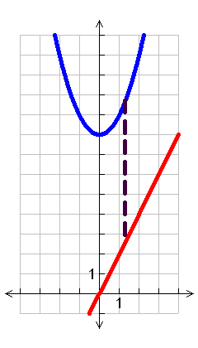The graphs of  and  are shown. Let  be the vertical distance between the graphs.

* 1. Write a function for .
  2. For what value(s) of *x* is the vertical distance 10?
  3. For what value of *x* is the vertical distance a minimum?

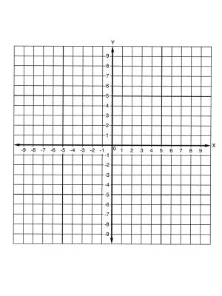7. Write the equation in graphing form of a circle with center at (-1, -1) with that passes through the point (0,5).

(graph it out, it might help!)

8. Change the equation below into graphing form of a circle. Then state the center and radius.

x2 + 6x – 1 + y2 – 10y = 8

9. If these two functions represent parts of a roller coaster, where x is the time into the roller coaster and f(x) and g(x) are the heights, which one is traveling faster at 4 seconds into the ride?

f(x) = -(x -3) + 12 g(x) = 0.5(3)x

10. Given the function $f\left(x\right)= \frac{2x}{5}-4$.

a. Find the inverse of $f\left(x\right)= \frac{2x}{5}-4$.

b. Find f(3) + f -1(-3)