Geometry 3Tri C Review Name: _______________________________

*All work and answers should be on a separate sheet of paper.*

1. The regular polygon has radius 8 m.

a. Find 

b. Find 

c. Find *OX*.

d. Find *AB*.

e. Find the perimeter.

f. Find the area.

2. Use Euler’s Theorem to calculate how many faces a polyhedron has if it has 6 edges and 4 vertices.

3. Find the surface area of the cylinder

in terms of .



4. Solve for *x*. Round to the nearest tenth.

5. Find the volume and surface area of the figure.

6. The base of the prism is a regular hexagon. Find the volume of the prism in simplest radical form.



7. Find the volume of the cone in terms of pi.

8. What is the maximum volume of a square pyramid that can fit inside a cube that has sides 30 cm long?

9. Find the volumes of the two balls. Round your answer to the nearest hundredth.





10. Find the volume of the figure

given that both prisms have

equilateral triangles for bases.

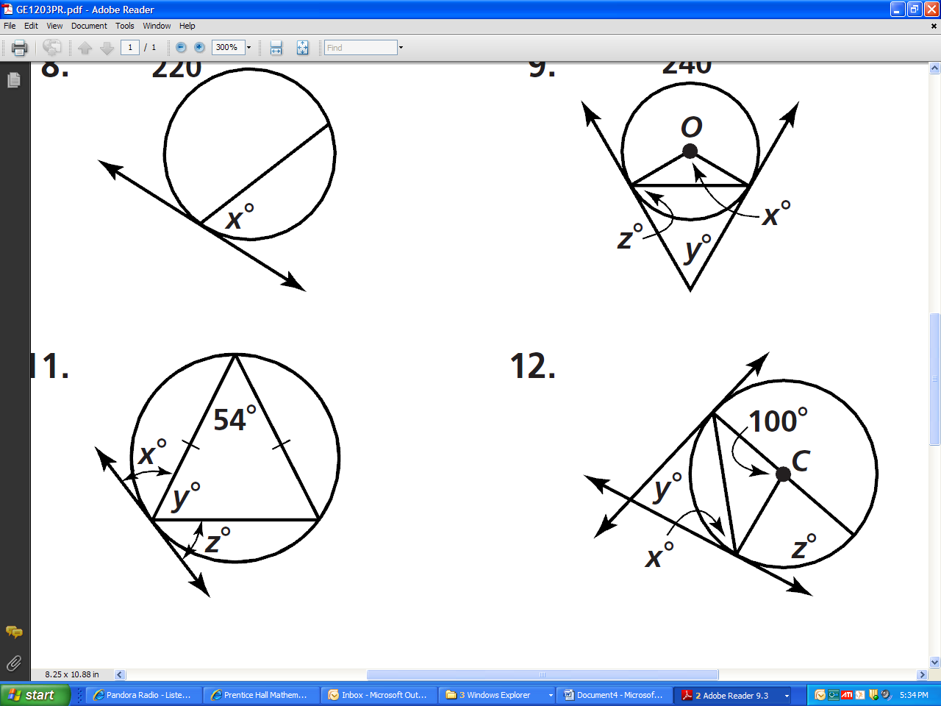11. Find the values of the variables.

12. Are the two figures similar? If so, give the similarity ratio.



13. The surface areas of two similar solids areandThe volume of the larger one isWhat is the volume of the smaller one?

14. Determine whether a tangent line is shown in the diagram. Explain.



15. Are the two figures similar? If so, give the similarity ratio.



16.  is tangent to circle *O* at *B*. Find the length of the radius *r*. Round to the nearest tenth if necessary.

17.   and  are all tangent to *O* (not drawn to scale).If  and  find the perimeter of 

18. Tell whether the polygon is inscribed in or circumscribed about the circle.

19.  is tangent to circle *A* at *B* and to circle *D* at *C* (not drawn to scale). If ** and ** find the length of  to the nearest tenth.



20. Find the value of *x*.

 feet



21.  and  are tangent to circle *O* and  bisects 

If  find the measure of 

22. Find the value of *x*.

23.  are diameters. Find the measure of 



24. The shipping crates shown are similar.

a. Find the similarity ratio of the crate on the left to the crate on the right.

b. Find the ratio of their surface areas.

c. Find the ratio of their volumes.



25. Find the value of the variable in the figure. You may leave your answer in simplest radical form.

26. If ** and ** find **



27. Find the value of *x*.

28. Write the standard equation for the circle.

a. center (-2, 1); r = 2

b. center (-27, 120); passes through (0,0)



29. Find *x* and *y*.

30. Given: **  **

Refer to the diagram to find the measure of each of the following:

a. **

b. **

c. **

d. **

31. Find the area.

32. Find the missing measure in the parallelogram. The diagram is not to scale.





33. Write the standard equation of the circle in the graph.

34. Find the volume of the figure to the nearest tenth.

35. Find the area.



36. Find the missing measures. Write all radicals in simplest form. 

37. A grid shows the position of a subway stop and your house. The subway stop is located at (0,3) and your house is located at (-15, -33). What is the distance between your house and the subway stop?

38. Find the lengths of the missing sides in the triangle.



39. Find the area.

40. Find the area of an equilateral triangle with side 6. Leave your answer in simplest radical form.

41. Find the area.

10 in.

6 in.

23˚

42. If a regular nonagon with 15-cm sides has an area ofwhat is the length of the apothem?

43. Find the area of the kite.

45˚

30˚

18

44. Given:  is the diameter of circle *O* and ** Find **

45. A highway makes an angle of  with the horizontal. This angle is maintained for a horizontal distance of 8 miles. To the nearest hundredth of a mile, how high does the highway rise in this 8-mile section?

46. Find the circumference of the circle.

47. The circumference of a circle is  Find the diameter, the radius, and the length of an arc of 

48. Find the area of the shaded region.



49. Find the area of a sector with a central angle of 240° and a radius of 10.7 cm. Round to the nearest tenth.

50. If an object falls at random on the figure, what is the probability that it will land in the shaded region?

51. On the following dartboard, the radius of the bulls-eye is 3 inches. The radius of each concentric circle is 3 inches more than the circle inside it. If a person throws randomly onto the dartboard, what is the probability that the dart will hit in area ?

52. In circle *O*,  and  are tangents.  bisects 



If  find the measure of .

53. Find the probability that an object falling randomly on the figure will land in the shaded area.

54. If  tell whether each equation must be true.

a. 

b. 

c. 

55. A map of Australia has a scale of 1 cm to 125 km. If the distance between Hobart and Sydney is 1063 km, how far apart are they on the map, to the nearest tenth of a centimeter?

56. Triangles *ABC* and *DEF* are similar figures. Find the lengths of *AB* and *EF*.

57. The polygons below are similar, but not necessarily drawn to scale. Find the values of *x* and *y*.



58. Find the area of the shaded portion of the figure in terms of pi. Dimensions are in feet.

59. Find the value of  and .

60. The length of a leg of a  triangle is 10 cm. Find the length of the hypotenuse.

61. Two trapezoids have areas  and  Find their similarity ratio.

62. Write a tangent ratio for 

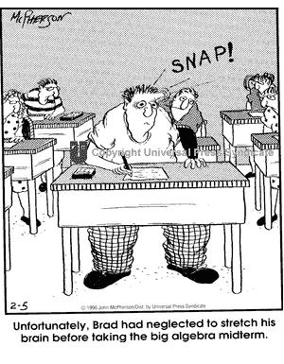

63. Write a sine ratio for 



64. A slide 2.9 m long makes an angle of 30° with the ground. How far above the ground is the top of the slide?

65. Find the value of *x* to the nearest degree.



66. Find the value of *x* if ** and ** *(not drawn to scale)*



67. Find the value of the variable.



***Reminders*:**

* Your exam will primarily cover chapters 10 - 12
* If you would like additional exam review,

use the “Extra Practice” from your book.

(Pg. 734 – 739, odd answers in back of book)

* Your old tests and quizzes are also good resources for review.