Lesson 1.1.1
- 1-2. Not a good suggestion. Any input x ≤ −20 will not give the negative output the customer requested.
- 1-3. See below:
  - The output from the first machine is −2; the output from the second machine is 4.
  - Not possible. The output of the second machine is always positive regardless of the input.
- 1-4. See below:
  - (x − 2)² could not be last, because the output is negative, and squaring a number makes it positive. 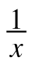 could be last, but is probably not last because the output is not a fraction.
  - Since the input is 0, could not be first because it would require dividing by 0.
  - The correct order is (x − 2)², , 4x − 32.
  - The correct order is , 4x − 32, (x − 2)².
- 1-5. See below:
  - The correct order is −2x + 34, (x − 2)², 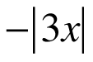, 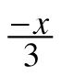 − 10.
  - The correct order is , − 10, (x − 2)², −2x + 34.
- 1-6. See below:
  - y = x² − 6 and then y = 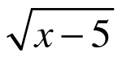.
  - Yes, reverse the order of the machines (y = and then y = x² − 6) and use an input of x = 6.
- 1-7. See below:
  - 54
  - −7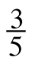
  - 2
  - 2.93
- 1-8. See below:
  - 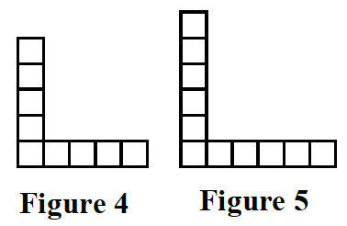
  - It grows by adding two tiles each time.
  - 1; The top and right tiles are removed, since the pattern is to add two tiles to expand each figure.
- 1-9. See below:
  - −59
  - 17
  - −72
  - 6
  - −24
  - −25
  - 25
  - −25
  - 7
- 1-10. See below:
  - y = 1
  - y = 3
  - y = 9

